Temasek Polytechnic

School of Informatics and IT

**Diploma in Information Technology (IT)**

Project Plan

**Project Particulars**

|  |  |
| --- | --- |
| **Tutor** | Mr. Mel Goh |
| **Class** | P03 |
| **Project Title** | Delonix Regia Hotel Management System |

**Project Team’s Particulars**

|  |  |
| --- | --- |
| **Matric Number** | **Student Name** |
| **1505447A** | **Kenji Leong** |
| **1505081H** | **Koh Jia Cheng** |
| **1502784J** | **Goh Mao Cheng** |

Revision History

|  |  |  |  |
| --- | --- | --- | --- |
| **Date** | **Version** | **Description** | **Author** |
| 10/5/17 | 1.0 | I revised the project schedule in terms of phases so that our team will be able to complete it on time | Kenji Leong |
| 10/5/17 | 1.1 | I revised the work breakdown structure so that our team will have a better guideline to follow | Goh Mao Cheng |
| 10/5/17 | 1.2 | I’ve revised the work by changing the scope of the objective, as well as various assumptions | Koh Jia Cheng |
|  |  |  |  |

**Table of Content**

**1 Introduction** **4**

1.1 Objectives and scope of the project (Jia Cheng) 4

1.2 Assumptions and constraints (Jia Cheng) 4

1.3 Definitions and acronyms (Goh Mao Cheng) 5

**2 Roles and responsibilities (Goh Mao Cheng)** **6**

**3 Estimates and project schedule** **6**

3.1 Work breakdown structure (Goh Mao Cheng) 6

3.2 Project Schedule (Kenji Leong) 8

3.3 Budget Summary (Jia Cheng) 9

**4 Risk Management Plan (Kenji Leong)** **11**

**References** **12**

# **1 Introduction**

## **1.1 Objectives and scope of the project (**Jia Cheng**)**

In the TOR (Terms of Reference), it’s been mentioned there are a lot of stuff and functionalities to be accomplished in this project. However, with limited time, power and resource. We will be developing a software with functions like

1. Reserving a room

a. Customer/Staff to do the reserving

2. Checking in and Checking out

3. Modifying Customer/Staff info (Create/Delete/Update/Read)

4. Taking in Customers’ feedback and Overall Satisfaction

5. Viewing Room Statuses

*It can be prone to revision if hardware availability of other unpredicted events were to occur

As the Project Specification is very vague, paired with the lack of resources, the previously mentioned functions can change respectively according to revision of what fits best. It can be also even more complicated and better compared as of now.

At the end of the project, we will make sure that the software will at least be able to reserve a room by a staff, checking a room availability and taking in customer’s feedback.

## 1.2 Assumptions and constraints (Jia Cheng)

Firstly, there isn’t enough human resource, to complete the project to its fullest. This is a team of 3 members doing this Hotel Management System, so not much can really be done in a short period of time. In this case (3~4 weeks). It’s very impractical to assume we will meet all the objectives given it’s a software for enterprise scale and we have to do it with 3 people within 3~4 weeks.

Secondly, resources such as computers are also lacking technologically wise. We’re working on this on our old laptops, hence there might be many problems with Visual Studio which is the program which we will start the build from. Problems such as opening, compiling, not updated, motherboard doesn’t support the latest version, utterly slow compiling and building (i5 cores).

Thirdly, within 3~4 weeks, there are also constraints within the members itself. Times when we will need to meet up and settle the project or to discuss the current progress, it can be hard to settle down a time as they might have their own personal problems and schedule to account for.

Fourthly, we are not just simply working for Mr Wang, we are students having other assignments as well, within such a small and tight schedules filled with many other important assignments as well, this is very unreasonable to come up with an enterprise-usable software, furthermore, given our lack of expertise and experience, it’s practically impossible unless maybe if we only have this one subject to deal with

Fifthly, we are also lacking in monetization, which would cease the process of actually having a server to operate as well as proper system we can work with. Adding on, this would also mean that we’re not paid.

Assumptions wise, we will assume that the plan all along was to develop a simple software to aid some parts of the Hotel Management Systems like Checking in and out, Reserving a Room, Updating client’s database and the likes. Basically a fairly simple software, and not a really coding complicated one like unless we’re given proper specifications on what Mr Wang really wants.

We will also assume that we have already watch the video (which was not even posted, even though mentioned that it would be posted in week 3) which is about the interview between us and Mr Wang about the various specifications. Which hence, the final product would be what Mr Wang actually wanted.

## 1.3 Definitions and acronyms (Goh Mao Cheng)

UI - UserInterface

UX - UserExperience

F1 / USM - Feature one (User Management)

F2 / RTM - Feature two (Rates Management)

F3 / RSVM - Feature three (Reservation Management)

F4 / OB - Feature four (Online Booking)

F5 / CI - Feature five (Check-in)

F6 / CO - Feature six (Check-out)

F7 / SHS - Feature seven (Supplementary Hotel Services)

F8 / RP - Feature eight (Reports)

F9 / HKP - Feature nine (Housekeeping)

F10 / HA - Feature ten (Hotel Administration)

F11 / ACC - Feature eleven (Accounting)

F12 / POM- Feature twelve (POS Management)

F13 / CLM - Feature thirteen (Client Management)

ADM - Administrator

MNG - Manager

STF - Staff

CUS - Customer

# 2 Roles and responsibilities (Goh Mao Cheng and Kenji)

**Kenji**

· Plan initial and next iteration

· Monitor and Manage any changes

· Design Login, Register and Update Profile Page

· Develop Login, Retrieve Hotel Lost, Book and Create Hotel functionality

· Design Database for Administrator

· Define Evaluation Objective and approach for Unit Testing

· Plan on how to integrate the components into the system

· Refine and Integrate into system

**Jia Cheng**

· Design Home, Hotel List and Details Page

· Design Database for Staff

· Develop Register, Rating and Payment Module

· Help in Unit Testing

· Help to refine and integrate into the system

**Mao Cheng**

· Design Reviews, Checkout and Contact Us Page

· Design database for Customer and Hotel Information

· Develop Update Profile for customer and Hotel, Delete and a review section for customer

· Help in Unit Testing and refining the requirements

# 3 Estimates and project schedule

## 3.1 Work breakdown structure (Goh Mao Cheng)

Task 1 - Requirements Engineering (1-2 days)

1.1 - Plan to meet the client (manager)

1.2 - Meet client (manager)

1.3 - Identify what the client wants the software to do (manager)

1.4 - Compile a list of specifications that the client wants for the software (manager)

1.5 - Submit the specification list (manager)

Task 2 - Analysis and Design (1 month)

2.1 - Read up on the specification list and understand what the client wants (programmer)

2.2 - Produce a system architectural designs (programmer)

2.3 - Produce a drafts of user interface designs (programmer)

2.4 - Produce database designs (programmer)

Task 3 - Implementation/Coding (2 months)

3.1 - Begin coding the features (programmer)

3.2 - Code and touch up on the user interface (programmer)

Task 4 - Testing (1 month)

4.1 - Conduct manual testing (programmer)

4.2 - Conduct beta version testing (staff and programmer)

4.3 - Write report on the test results (staff and programmer)

4.4 - Debug the software (programmer)

4.5 - Write report on final product (programmer)

Task 5 - Deployment

5.1 - Application distribution to selected customers before official release (manager)

5.2 - Email the customers about the release (manager)

5.3 - Provide feedback (customers)

5.4 - Collate feedback (manager)

5.5 - Official Application release (manager)

## 3.2 Project Schedule (Kenji Leong)

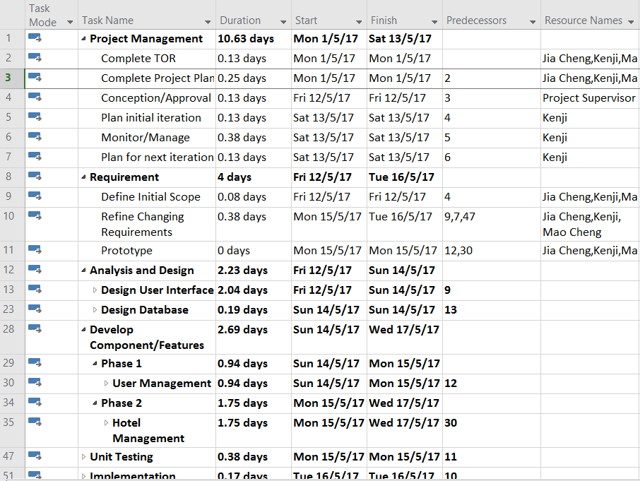

As shown above, upon approval, our team has decided to develop the hotel management software in different phases or iteration. Firstly, as the project I have come up with initial iteration which is to complete our user management section which includes Login, Logout, Register and Update Profile first. During the process, I will monitor and manage any changes required for the requirements. After consulting with the team members, we have agreed with the initial iteration.

The first iteration includes firstly; we would need to design the user interface and database. Next, each of do one of the feature for user management. After that the prototype will then be developed, where we will then send for unit testing for feedback. Lastly, we will refine the requirement and then implement it into the system.

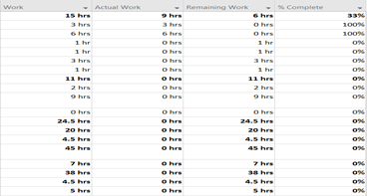

As shown above, the first iteration will be completed on the 16/5/2017, which gives us around three weeks left for the second phase or iteration which is to develop the hotel management features.

Besides, as shown above, I also included another section such as Work, Actual Work, Remaining Work and number of percent completed. This is because we do not spend 24 hours fully for our task. For example, after they are done, then they include it into Action Work where it will then calculate the estimate of work left for each task. Thus, the work tab is there for the members to estimate how long they need to finish their work.

## 3.3 Budget Summary (Jia Cheng)

**Manpower Costs:**

Members: 3

Salary per Month for each Software Engineer: 9000USD

Estimation of Project Final Deployment: 12 months

============================================

**Total Manpower Costs:**

108,000 USD (152,000SGD)

**Software Costs:**

Visual Studio Community for 3: FREE

Adobe Dreamweaver CS6 for 3: 1200USD (1680USD)

Adobe Photoshop CS6 for 3: 2100USD (3000SGD)

IBM Rational Functional Tester (Authorized User License): 14300USD (20000SGD)

Window Server 2008 R2 Standard: 1210 USD (1700SGD)

============================================

**Total Software Costs:**

18,810USD (16,380SGD)

**Total Hardware Costs:**

Desktop with i7-cores and solid graphic cards for Photoshop rendering for 3:

· Core i7-6800k

· Corsair H105 73.0 CFM cooler

· ASRock X99 Extreme 3 ATX LGA2011-3 Motherboard

· Team Dark 2x8GB ram DDR4-2000 Memory

· Crucial MX300 525GB 2.5 SSD

· Seagate Barracuda HD 2TB

· Zotac GeForce GTX 1080 AMP! Edition

· Phanteks Enthoo Pro ATX PC case

· EVGA SuperNOVA G3 850W Gold

· Window 10 Home OEM 64-bit OS

*PC specs might be overestimated for the needs

Price per pc of the above set up: 2500USD (3510SG)

For 3: 7500USD (10530SGD)

PowerEdge T30 Mini Tower Server; Contact Dell for info:

Estimated Price: 3000USD (4210SGD)

============================================

**Total Hardware Costs:**

10,500USD (14,740SGD)

---------------------------------------------------------------------------

**FINAL TOTAL PRICE:**

137,310USD (183,120SGD)

*Prices are approximated. Given the lack of experience, this is prone to many revisions.

**Prices catalog:**

**Software:**

Visual Studio:

<https://www.visualstudio.com/vs/>

Dreamweaver CS6:

<https://www.cnet.com/products/adobe-dreamweaver-cs6-complete-package-series/prices/>

Photoshop CS6:

<http://prodesigntools.com/products/adobe-cs6-pricing-list.html>

IBM Tester:

<https://www-112.ibm.com/software/howtobuy/buyingtools/paexpress/Express?P0=E1&part_number=D53NFLL,D530BLL,D54SHLL,D0BGLLL,D0BGMLL,D0BGNLL&catalogLocale=en_US&Locale=en_US&country=USA&PT=jsp&CC=USA&VP=&TACTICS=&S_TACT=&S_CMP=&brand=SB03>

**Hardware:**

PC:

CPU:<https://www.superbiiz.com/detail.php?name=I7-6800KBX&c=CJ>

CPU Cooler:<https://www.amazon.com/dp/B00HKEI3EY/?tag=ch0783-20>

Mother Board:<https://www.superbiiz.com/detail.php?name=MB-X99EXM3&c=CJ>

RAM:<https://www.newegg.com/Product/Product.aspx?Item=N82E16820313795&nm_mc=AFC-C8Junction&cm_mmc=AFC-C8Junction-Mark%20Robinson-_-na-_-na-_-na&cm_sp=&AID=11517614&PID=7643828&SID>

SSD:<https://www.amazon.com/dp/B01IAGSD68/?tag=ch0783-20>

HD:<https://www.amazon.com/dp/B01IEKG402/?tag=ch0783-20>

GPU:<https://www.amazon.com/dp/B01GCAVRSU/?tag=ch0783-20>

Casing:<https://www.amazon.com/dp/B00K6S1B3Q/?tag=ch0783-20>

PSU:<https://www.newegg.com/Product/Product.aspx?Item=N82E16817438092&nm_mc=AFC-C8Junction&cm_mmc=AFC-C8Junction-Mark%20Robinson-_-na-_-na-_-na&cm_sp=&AID=11517614&PID=7643828&SID>

OS:<https://www.amazon.com/dp/B00ZSI7Y3U/?tag=ch0783-20>

**Server:**

Server:<http://www.dell.com/sg/business/p/poweredge-t30/pd>

Server OS:<https://blog.zubairalexander.com/windows-server-2008-r2-pricing/>

# 4 Risk Management Plan (Kenji Leong)

Risk management refer to the process of identifying, assessing and controlling those risks to minimize the threats that can negatively impact the project plan. Besides, risks are characterized by the level of impact and the chances of it happening in the future.

**Project Risks**

Firstly, project risk is the first categories as they are risks that threaten the project plan. For example, when developing a feature, both members may come up with different design due to the lack of communication. As a result, communication can become an issue between the team members. Also, another project risk also can be the lack of manpower due to unforeseen circumstances such team member may be sick. As a result, the deadline will need to be extended or other members need to takeover and this would affect the rest of the project schedule.

Besides, technical risk is another category which refer to risk that can affect the quality and the timeliness of the software that is being produced. For example, initially the requirements from the team is to complete on five features only. However, after gaining feedback from sponsor or customer. As a result, they would need to refine their requirements due to more features needed to be implement. Thus, depending on the technical skills of the team members, they might not be able to meet the response of the changing requirements. By doing so, the quality of the software may not be as intended and there is higher probability that the deadline will need to be extended as they are not able to produce the software on time.

Lastly, business risk are risks that threaten whether the software will be used depending on how the company market the software. For example, even if the company produce one of the best software that is available on the market. However, due to poor marketing from the marketing team such as not advertising enough. As a result, no one will ever know about this software and the company will experience loss rather than profit.

**Strategies of Risk Management**

Firstly, risk avoidance can be used to avoid any project risk such as software being buggy. For example, before the team start the project, they would have to research and use software that is consistently update because if they were to use an old software, chances of the software being buggy is high. As a result, if the old software were to crash then they would have to redo all their work again. Thus, risk avoidance such as using a more updated software can help to solve project risk.

Besides, risk mitigation which refers to taking actions to reduce negativity of the risk can be used to help reduce technical risk. For example, after the team has finished integrating all their features and components into the system. They would need ensure to do unit testing such as sending out the prototype for the public to use. By doing so, they can gain feedback on what are the bugs that they need to fixed. As a result, when the software is released onto market, the chances of the software being well reviewed is much higher.

Lastly, risk contingency which refers to a plan devised for an outcome that is unexpected such as a backup plan and this can help to reduce business risk. For example, the marketing team needs to ensure that multiple plans when marketing their products such as if promoting the products on platform such as television does not work then another plan for can be used to promote on social media. As a result, this can help to reduce the chances of the product not selling as they are other plans available for it.

# References

<http://www.projectconnections.com/knowhow/burning-questions/difference-between-project-technical-risk.html>